DOKUZ EYLUL UNIVERSITY
ENGINEERING FACULTY
DEPARTMENT OF COMPUTER ENGINEERING

CME1252 PROJECT BASED LEARNING – II
FINAL REPORT
PROJECT – II

STAR TREK WARP WARS

by
Güney SÖĞÜT
Sefa ÇELİK
Hasan BALIKÇI
Deniz KATAYIFÇI

Lecturers
Assoc. Prof. Dr. Semih UTKU
Res. Asst. Fatih DİLMAÇ

IZMIR
22.04.2022

CHAPTER ONE
PROGRESS DESCRIPTION
During the proggres time, the suggested weekly program is followed step by step. First week, the ‘map.txt’ file was read and the main game design was composed. Additionally, first week, the menu and the data structures were accomplished. More importantly, in the first week, the ‘map.txt’ file’s elements were seperated into the map array. Second week, the player movements, timing process and implementations and backpack implementation were exactly done. In the third week, input queue implementation and static and moving number processes and attributes were consummate done. In the fourth week, a part of the computer movement was done adn the initial implementation of trap and warp devices were done. In last week, remaining part of the computer movement and other remaining parts of the project were through done with additional features.

CHAPTER TWO
TASK SUMMARY

Completed Tasks
Güney Söğüt: In the first week of our project, we created the main game design with classes. Also during the first week, we read the maze file and assign the elements to an Object array. In the second week, I created the backpack stack and input queue (circular queue). Moreover, in the second week, I accomplished the timing and player movement. In the third week, the static numbers are done. Furthermore, I made the input queue implementation with 15 elements size and its effect functions: adding the top of the queue to the maze every 3 seconds and printing function to the input queue place. Additionally, I made the backpack implementation. In the fourth week, trap and warp devices’ initial implementation (their timings and places) was finished. Last week, the computer movement were done. Moreover, the remaining parts of the project were done.

Sefa Çelik: In the project, I first worked on the formation of classes and the determination of the necessary attributes. The next week, I designed the menu and created a colorful maze. In the following weeks, I worked on computer movement and targeting algorithms and added a story to the game and completed the menu.

Hasan Balıkçı: In the first week of our project, we created the main game design with classes. Also during the first week, we read the maze file and assign the elements to an Object array. In the second week I made some parts of player movement. In the third week I tried to optimize our timer. In the fourth week I seperated all functions to suitable classes. Last week the remaining parts of the project were done.

Incomplete Tasks: Reasons and Explanations
There is no incompleted tasks.

Additional Improvements
Güney Söğüt: Coloring for the maze, numbers, player and computer.

Sefa Çelik: I added a stable game background to the project. In this way, I created the ambiance of the game. I placed the menu and all the options in it on this background, so the game seems to flow from the sky in a frame. I added an algorithm where we can print everything in the maze in a different color. I added a story to the game.

Hasan Balıkçı: No additional improvement has added.

CHAPTER THREE
EXPLANATION of algorıthms

Screenshots
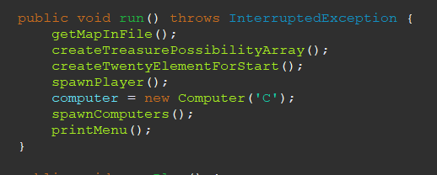

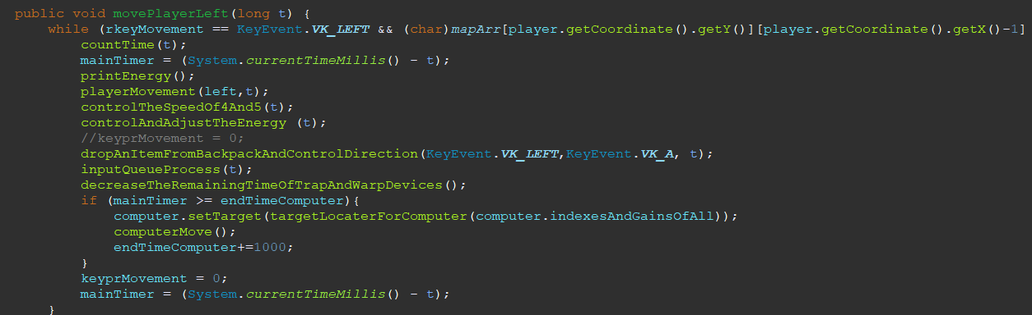

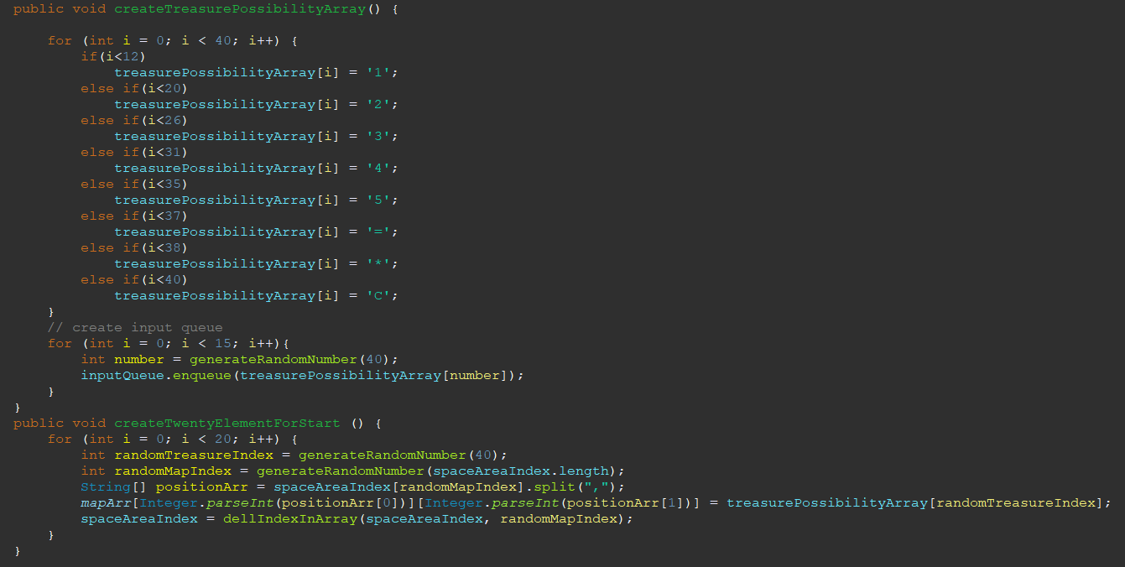
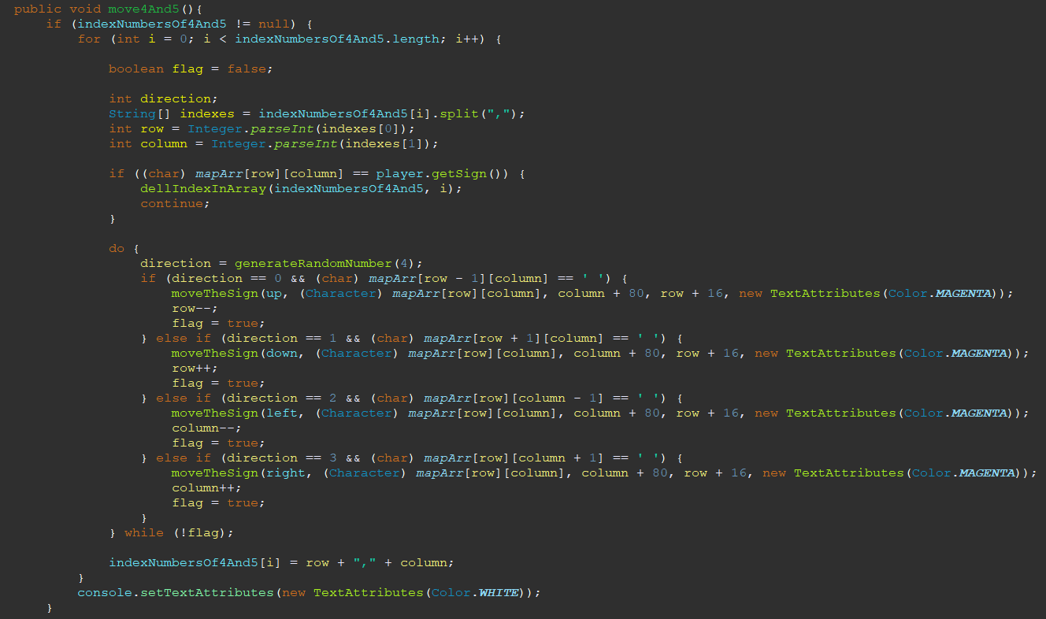

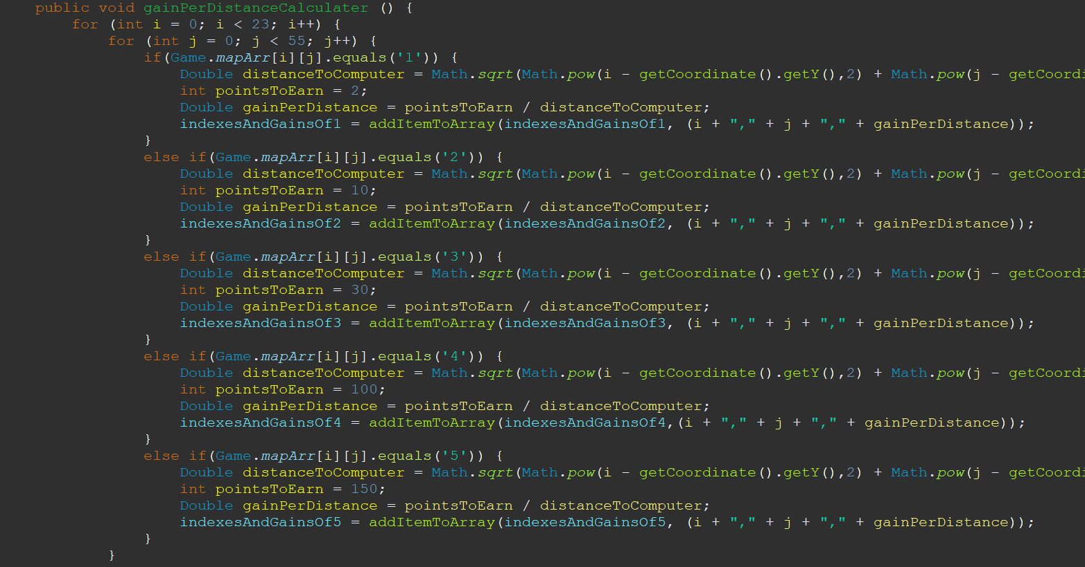

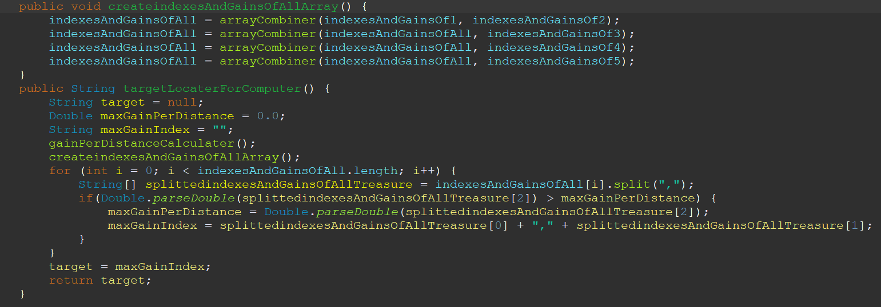

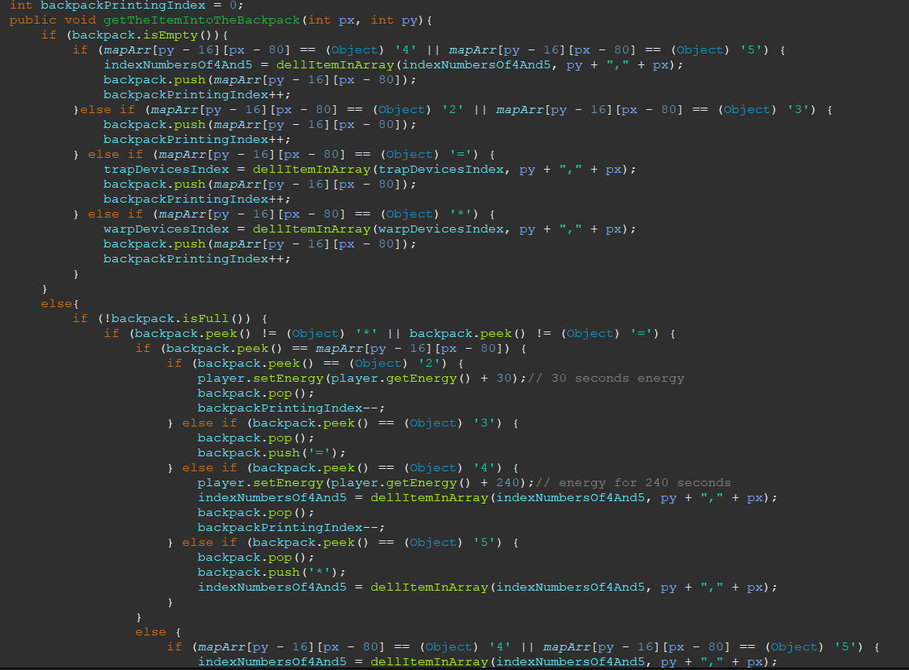
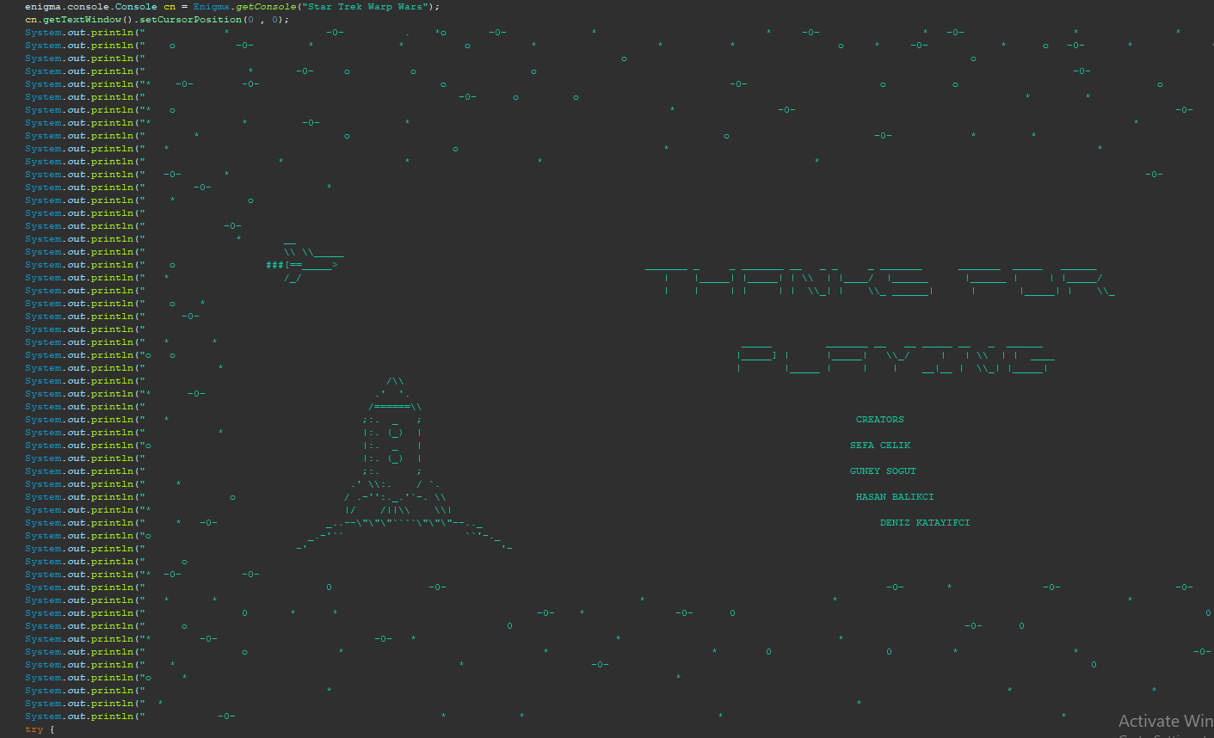

Functions
run()
gamePlay()
trapDeviceProcess()
warpDeviceProcess()
decreaseTheRemainingTimeOfTrapAndWarpDevices()
updatePlayerNewCoordinate(String direction)
updateComputerNewCoordinate(String direction)
playerMovement(String direction, long t)
moveTheSign(String direction, char sign,int px, int py,TextAttributes attributes)
updateTheScoreForPlayer(int px, int py)
controlTheSpeedOf4And5(long t)
controlAndAdjustTheEnergy ()
movePlayerLeft(long t)
movePlayerRight(long t)
movePlayerUp(long t)
movePlayerDown(long t)
move4And5()
getMapInFile()
createTreasurePossibilityArray()
createTwentyElementForStart ()
printMenu()
printMaze()
printExit()
printStory()
printGameInfo()
addItemToArray(String[] srcArray, String elementToAdd)
dellIndexInArray(String[] srcArray, int delIndex)
dellItemInArray(String[] srcArray, String item) {
resultArray = null;
arrayCombiner(String[] firstArray, String[] secondArray)
countTime(long t)
cleanConsole()
spawnPlayer()
spawnComputers()
printCircularQueue(CircularQueue circularQueue)
addInputQueueElementToTheMaze()
inputQueueProcess(long t)
printBackpack(Stack stack)
dropBackpackItem(int px, int py)
droppingProcess(int px, int py, int a, int b)
dropAnItemFromBackpackAndControlDirection(int KeyEventDirection, int KeyEventWASD, long t)
getTheItemIntoTheBackpack(int px, int py)
printEnergy()
printPlayerLive()
gainPerDistanceCalculater ()
createindexesAndGainsOfAllArray()
targetLocaterForComputer(String[] indexesAndGainsOfAllTreasure)
computerMove()

Algorithms and Solution Strategies
Güney Söğüt: During the timing process, I initially assign the 1000 times of the processes’ loop durations’s second units. There is a if block to check for instance if 3000 ms is passed for input queue, if true, the program enter the statement then after the all progress finished, it increases the input queue time check statement’s variable by 3000.

In the backpack implementation progress, I called the function after the player sign’s index has changed in order to avoid creating different functions for all situations.

Moreover, I created moveTheSign method in order to carry on all moving processes.

Additionally, I created methods in order to avoid repeat the similar expressions in the whole program. I implemented the with dynamic parameters to make them well-processive.

Sefa Çelik:
While setting up the computer algorithm, I followed a two-step solution. In the first stage, I needed to find the object that would earn the most per distance, in the second stage, I planned to make sure that he orients and reaches the object that will bring the most profit to the business.
When creating the first stage, I first scan the entire map and calculate the distance of the positions of the objects in it to the computer. I then add these objects to their array as a string expression. This string contains 2 commas and 3 objects. I keep the position of that object in the first part of the commas. In the last part, the score it will bring per distance. Then I combine these 5 arrays and I have an array with the profit rates of all the objects. I go around this array and choose the object with the most profit per distance and set a target for the computer.
The algorithm I planned for the second phase was first searching for whether it was up or down or aligned on the y-axis. Then he started to act accordingly. When he came to a wall, he would start looking to see if it was to the right or to the left and turn in that direction. Secondly, it was to write down what he had to do when he was stuck in a wall, that is, when there were walls in both directions. Since the algorithm I wrote for this place did not work, we removed all computer artificial intelligence from the project and switched to a primitive artificial intelligence, that is, a computer artificial intelligence that acts randomly.
The addItemToArray function takes an array as a parameter and creates another array with one extra length, then moves everything in the first array to the last array and adds the desired element to the end.
The delIndexInArray function creates an array and adds all indexes except the specified index to the last array with the addItemToArray function.
The delItemInArray function takes an array and creates an empty array. It travels the objects in the array it receives and adds the items other than the object to be deleted to the array it has created.
The returnIndexInArray function takes an array and creates an empty string. It navigates through the array and when it reaches the desired index, it assigns the object to the empty string. It then returns the string.
The arrayCombiner function takes two arrays and creates an array with the total length of the two, then throws the first array into it, and discards the remaining parts of the second array and combines the two arrays.

Hasan Balıkçı: I used file reader codes of Java in order to read map file. When writing player movements I used Coordinate class. If player wants to go right program is going to add 1 to x coordinates. c.setX(c.getX()+1) this is the piece of code that allows program to do so. Same mechanism goes for every direction of movement. While optimizing timer I used systemTimeMillis() instead of thread sleep. And for seperating functions to suitable classes I created an object of that class in order to access functions.

CHAPTER FOUR
PROBLEMS ENCOUNTERED
Güney Söğüt: I initially truggled with our game screen, because of my computer’s screen. The font is too big and the game screen is too wide, so that, the computer can’t be able to compile it well. While the player movement progress in the game, the maze didn’t at the correct place and the player sign passed all the walls without stuck and deleted them. Additionally, I mostly struggled with timing. In timing implementation, I couldn’t find the best fit for our structure. I tried to implement it as seconds, however, this time I couldn’t check the small differentiations. At last, I decided to implement it as milliseconds then it worked correctly as I want.

Sefa Çelik:
printFunctions
computerFunctions
arrayFunctions
loadFunction
The functions I had the most difficulty with while creating the functions I wrote above were computer functions. I tried to create a two-stage motion algorithm for Computer. In the first stage, it was the algorithm to select the object that would bring the most points compared to its distance. Although I have progressed fully until this part, I could not fully run the function I wrote in the action part of computer artificial intelligence. That's why we had to switch to a primitive artificial intelligence that acts randomly. Although there were simple positional problems in the writing of other functions, they were easily solved.

Hasan Balıkçı: I had a hard time while seperating functions to classes. The variables we used in another class caused problems. “static” prefix made some problems. All classes have connection with each other because of this sometimes I had to create an object in order to access a variable in the other class.

CHAPTER FIVE
conclusıon
First of all, the “Star Trek Warp Wars” project is accomplished perfectly without any unfinished part. The solution path was argued. Communication has been carried on WhatsApp and Discord. Methods, possible solution ideas for the strategy have been produced. Furthermore, the control progress of the project was done each completed part. New suggestions for solving problems were covered in order to improve the project. Thanks to this project, we’ve tried to work more efficient and tried to schedule ourselves perfectly. In addition, we developed ourselves in Java programming and solution – oriented thinking.

REFERENCES

- Y. Daniel Liang, "Introduction to Java Programming", tenth edition. ISBN: 0133761312
- Bruce Eckel, "Thinking in Java", 4th ed, 2007.
- Java mother site : https://www.oracle.com/technetwork/java/index.html.
- Ken Arnold, James Gosling and David Holmes, "The Java Programming Language", 4th ed, 2005.
- Oracle Java Sstem documentation : https://docs.oracle.com/javase/7/docs/api/java/lang/System.html

AppendIx A
POSTER of the Project

AppendIx B
Code of the Project

APPENDIX C
TEAM WORK PROOF

